PROGRAM-8
Problem Statement
An Automated Teller Machine (ATM) allows users to perform banking operations such as depositing money, withdrawing money, and checking their account balance. This case study aims to develop a menu-driven Python program that simulates ATM operations. The program processes repeated transactions, maintains the account balance, validates transaction amounts, enforces withdrawal limits, and generates a transaction summary.
2. Objectives
- To develop a menu-driven ATM simulation using Python.
- To perform deposit and withdrawal operations.
- To display the current account balance.
- To validate transaction amounts and reject invalid operations.
- To enforce the specified withdrawal limit.
- To maintain a record of transactions.
- To display a summary of completed transactions.
3. Assumptions
- The initial account balance is ₹5,000.
- The maximum withdrawal per transaction is ₹10,000.
- Deposits and withdrawals must be positive amounts.
- A withdrawal cannot exceed the available account balance.
- The user can perform multiple transactions until choosing the Exit option.
- Only successful deposits and withdrawals are included in the transaction summary.
- The program uses basic Python concepts such as variables, loops, conditional statements, lists, and arithmetic operators.
4. Algorithm
- Start.
- Initialize the account balance to ₹5,000.
- Initialize an empty list to store successful transactions.
- Display the ATM menu.
- Accept the user's choice.
- If the choice is Deposit, input the amount and validate it. If valid, add it to the balance.
- If the choice is Withdraw, check that the amount is positive, within the withdrawal limit, and does not exceed the balance.
- If the choice is Balance Enquiry, display the current balance.
- If the choice is Transaction Summary, display all successful transactions.
- If the choice is Exit, terminate the program.
- For an invalid menu choice, display an error message.
- Repeat the menu until the user exits.
- Stop.
5. Flowchart
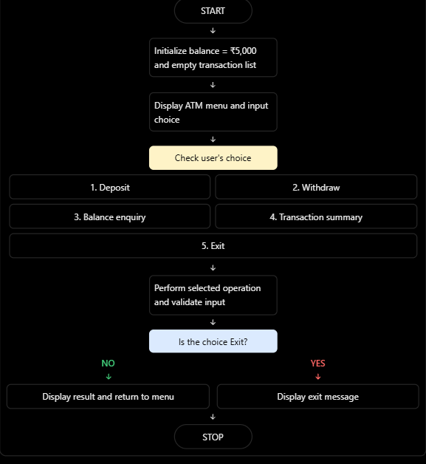
6. Pseudocode
START

balance = 5000
withdrawal_limit = 10000
transactions = empty list

WHILE True:
DISPLAY ATM MENU
INPUT choice

IF choice == 1:
INPUT deposit_amount

IF deposit_amount > 0:
balance = balance + deposit_amount
RECORD deposit
DISPLAY updated balance
ELSE:
DISPLAY invalid amount

ELSE IF choice == 2:
INPUT withdrawal_amount

IF withdrawal_amount <= 0:
DISPLAY invalid amount
ELSE IF withdrawal_amount > withdrawal_limit:
DISPLAY withdrawal limit exceeded
ELSE IF withdrawal_amount > balance:
DISPLAY insufficient balance
ELSE:
balance = balance - withdrawal_amount
RECORD withdrawal
DISPLAY updated balance

ELSE IF choice == 3:
DISPLAY balance

ELSE IF choice == 4:
DISPLAY transaction summary

ELSE IF choice == 5:
DISPLAY exit message
BREAK

ELSE:
DISPLAY invalid choice

STOP
7.Python Source Code

balance = 5000
withdrawal_limit = 10000
transactions = []

while True:
print("\n===== ATM MENU =====")
print("1. Deposit")
print("2. Withdraw")
print("3. Balance Enquiry")
print("4. Transaction Summary")
print("5. Exit")

choice = input("Enter your choice: ")

if choice == "1":
amount = float(input("Enter deposit amount: "))

if amount > 0:
balance += amount
transactions.append(("Deposit", amount, balance))
print("Deposit successful.")
print("Current balance: Rs.", balance)
else:
print("Invalid amount.")

elif choice == "2":
amount = float(input("Enter withdrawal amount: "))

if amount <= 0:
print("Invalid amount.")
elif amount > withdrawal_limit:
print("Withdrawal limit exceeded.")
elif amount > balance:
print("Insufficient balance.")
else:
balance -= amount
transactions.append(("Withdrawal", amount, balance))
print("Withdrawal successful.")
print("Current balance: Rs.", balance)

elif choice == "3":
print("Current balance: Rs.", balance)

elif choice == "4":
print("\n===== TRANSACTION SUMMARY =====")

if len(transactions) == 0:
print("No transactions found.")
else:
for transaction in transactions:
print("Type:", transaction[0],
"| Amount: Rs.", transaction[1],
"| Balance: Rs.", transaction[2])

print("Final balance: Rs.", balance)
print("Total transactions:", len(transactions))

elif choice == "5":
print("Thank you for using the ATM.")
break

else:
print("Invalid choice. Please try again.")
8. Test Cases
Test case | Operation | Input | Expected result
1 | Deposit | ₹2,000 | Balance becomes ₹7,000
2 | Withdraw | ₹1,000 from ₹5,000 | Balance becomes ₹4,000
3 | Balance enquiry | Choice 3 | Displays current balance
4 | Withdraw | ₹12,000 | Withdrawal limit exceeded
5 | Withdraw | ₹6,000 from ₹5,000 | Insufficient balance
6 | Deposit | ₹0 | Invalid amount
7 | Transaction summary | Choice 4 | Displays successful transactions
8 | Exit | Choice 5 | Displays exit message and stops
9.Output
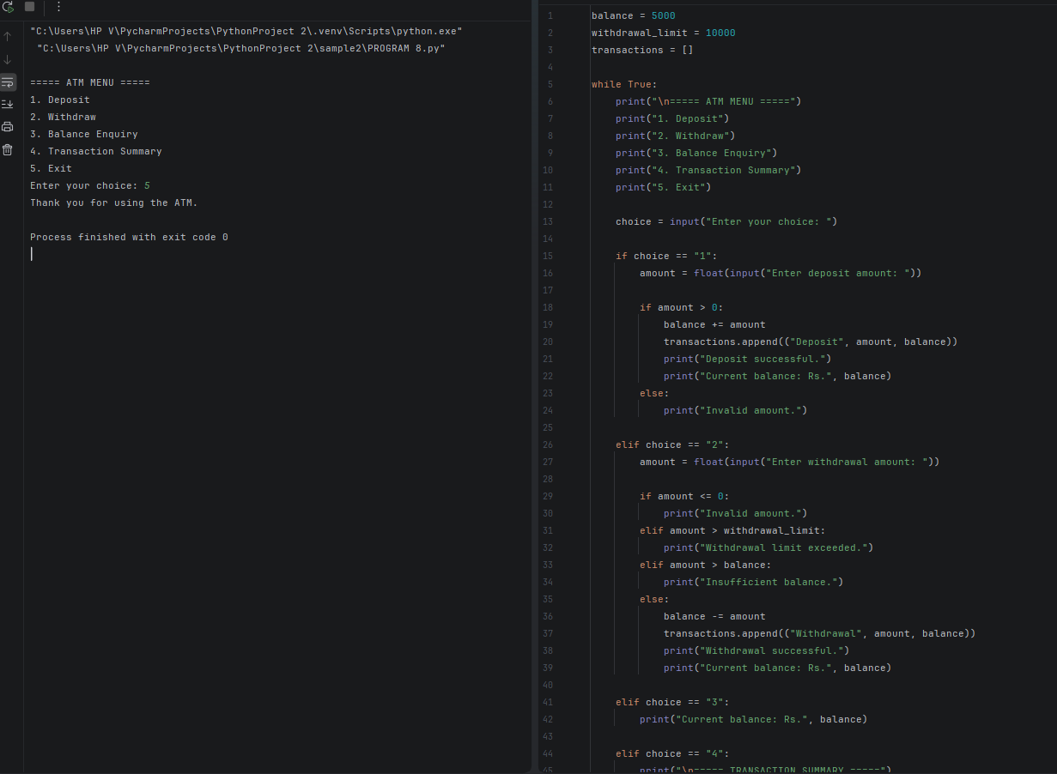
10. Conclusion
Thus, the Python program successfully simulates ATM operations, including deposits, withdrawals, balance enquiries, and transaction summaries. It validates transaction amounts, enforces withdrawal limits, maintains the account balance, and records successful transactions. This case study demonstrates the use of loops, conditional statements, lists, tuples, and arithmetic operations in Python.

